National College of Computer Studies

Paknajol, Kathmandu



Project On

“Techie Roo: E-commerce Mobile Phone Store”
as required for the partial fulfillment of the
B.Sc. CSIT 6th Semester affiliated to Tribhuvan University.

Submitted by: Submitted to:
Shrayam Manandhar Pratiksha Poudel
Spandan Bhattarai
Birat Jung Thapa

NCCS College National College of Computer Studies

Supervisor’s Recommendation

I hereby recommend that this project prepared under my supervision by SPANDAN BHATTARAI, BIRAT JUNG THAPA, and SHRAYAM MANANDHAR entitled
“TECHIE ROO: E-COMMERCE MOBILE PHONE STORE”
in partial fulfillment of the requirements for the degree of B.Sc. in Computer Science and Information Technology be processed for the evaluation.

…………………………………………
Pratiksha Poudel
Lecturer, BSc.CSIT
National College of Computer Studies NCCS College

Student’s Declaration

I hereby declare that we are the sole author of this work and that no sources other than that listed here have been used in this work.

…………………………………………
Shrayam Manandhar
Birat Jung Thapa
Spandan Bhattarai

2025-12-21

ACKNOWLEDGEMENT

We would like to express our deepest gratitude to NCCS College for providing the resources, platform, and unwavering support that made this project possible. The opportunities and guidance offered by the institution have been invaluable in shaping the direction and success of our work.
Our heartfelt thanks go to Mrs. Pratiksha Poudel, our esteemed lecturer, whose invaluable guidance, expertise, and encouragement have been instrumental in overcoming challenges and maintaining the quality of this project. Your mentorship has inspired and motivated us throughout this journey.
We also extend our sincere appreciation to our families, friends, and all the participants for their steadfast encouragement and thoughtful contributions. Your unwavering support has been a constant source of strength, inspiring us to give our best at every stage.
In conclusion, we are profoundly thankful to NCCS College, Mrs. Pratiksha Poudel, and everyone who contributed to bringing this project to fruition. Your collective efforts and support have been the foundation of its success.

Thanking You,

Spandan Bhattarai
Shrayam Manandhar
Birat Jung Thapa

BSc.CSIT 6th Semester

ABSTRACT

The TECHIE ROO: E-COMMERCE MOBILE PHONE STORE is a modern, web-based e-commerce platform designed to provide a seamless and efficient online shopping experience for customers seeking mobile phones and related accessories. The system is developed using HTML, CSS, JavaScript for the frontend, and Node.js with Express.js and SQLite for the backend, ensuring a scalable, secure, and user-friendly application.

The website enables users to browse a wide range of mobile phones and accessories categorized by brand, price, and specifications. Core features include a dynamic shopping cart, secure user authentication, and real-time order management. Role-based access control allows administrators, salespersons, and customers to interact with the system according to their responsibilities, ensuring efficient management of products, orders, and customer data.

JavaScript enhances interactivity through real-time cart updates and smooth navigation, while backend technologies ensure secure data handling using JWT authentication and password hashing. The integration of WhatsApp further improves customer communication by enabling direct interaction for order confirmation, support, and delivery coordination. The payment gateway integration enables the customer access the payment gateway i.e. Khalti to complete the online transaction

This project aims to modernize the traditional mobile phone retail business by providing a reliable and convenient online shopping solution. TECHIE ROO bridges the gap between physical stores and digital commerce, offering enhanced accessibility, improved customer engagement, and efficient business operations .

Table of Contents

Contents

Supervisor’s Recommendation ii
Student’s Declaration iii
ACKNOWLEDGEMENT iv
ABSTRACT v
  - INTRODUCTION 1
  - PROBLEM STATEMENT 1
  - OBJECTIVE 2
  - SCOPE 3
  - REPORT ORGANIZATION 4
    - Introduction 4
    - Background Study 5
    - System Analysis and Design 6
    - Implementation and Testing 7
    - Conclusion and Further Recommendations 8
CHAPTER 2: BACKGROUND STUDY 8
  - BACKGROUND STUDY 8
    - STUDY OF EXISTING SYSTEM 8
    - LITERATURE REVIEW 10
CHAPTER 3: SYSTEM ANALYSIS AND DESIGN 12
  - SYSTEM ANALYSIS 12
    - REQUIREMENT IDENTIFICATION 13
      - Functional Analysis 13
      - Non-Functional Analysis 14
    - FEASIBILITY STUDY 15
      - Technical Feasibility 15
      - Operational Feasibility 15
      - Economic Feasibility 15
      - Schedule Feasibility 16
    - DATA MODELING 16
      - Data Flow Diagram 16
      - ER Diagram 17
    - PROCESS MODELING 18
      - Flow Chart: 18
      - Use Case Diagram 19
      - Activity Diagram 22
      - Sequence Diagram 25
  - SYSTEM DESIGN 28
    - Architectural Design 28
    - Database Schema Design 29
CHAPTER 4: IMPLEMENTATION AND TESTING 30
  - IMPLEMENTATION 30
    - Tools used. 30
    - Implementation Detail of Module 30
  - TESTING 30
CHAPTER 5: CONCLUSION AND FUTHER RECOMMENDATION 32
  - LESSON LEARNT /OUTCOME 32
  - CONCLUSION 32
  - FUTURE RECOMMENDATION 32
References 33
Appendices 35
Snapshots of output: 35

Table of Figure:

Figure 1: System Analysis and Design 13
Figure 2: DFD Level 0 16
Figure 3 : ER Diagram 17
Figure 4: Flowchart 18
Figure 5: Use Case Diagram 21
Figure 6: Activity Diagram of Admin 22
Figure 7: Activity Diagram of Customer 24
Figure 8:Sequence Diagram 27
Figure 9 : Three tire architecture 28
Figure 10: Database Scheme 29
Figure 11 Home Page of Techie Roo 36
Figure 12 Product page of Techie Roo 37
Figure 13 Add to cart page of Techie Roo 37
Figure 14 Checkout of Techie Roo 38
Figure 15 Payment of Techie Roo 38
Figure 16 Login Page 39
Figure 17 Signup page 39
Figure 18 Contact Us page………………………………………………………………………..40
Figure 10 About Us page………………………………………………………………………....41

LIST OF ABBREVIATIONS

CSS: Cascading Style Sheets
CRUD: Create, Read, Update and Delete DFD: Data Flow Diagram
ERD: Entity Relationship Diagram HTML: Hypertext Markup Language JS: JavaScript
MySQL: My Structured Query Language
PHP: Hypertext Preprocessor

CHAPTER 1: INTRODUCTION

INTRODUCTION

Techie Roo is a comprehensive full-stack e-commerce web application specifically designed for mobile phone and accessory retail businesses. Built with modern web technologies, this platform combines the convenience of online shopping with personalized customer service through integrated WhatsApp communication. The application features a sophisticated role-based access control system supporting three distinct user types: administrators who manage the entire platform and business operations, salespersons who handle order fulfillment and customer communications, and customers who browse products and make purchases. The platform is built using Node.js and Express.js for the backend, vanilla JavaScript for the frontend, and SQLite3 for data persistence, making it lightweight yet powerful enough to handle real-world retail operations. The project addresses a critical gap in the e-commerce market where small to medium-sized phone retailers need an affordable, easy-to-deploy solution that doesn't sacrifice functionality or user experience. Unlike generic e-commerce platforms, Techie Roo is tailored specifically for phone retail with features like detailed product specifications, brand filtering, pre-owned device categories, and most importantly, seamless WhatsApp integration that allows customers to directly communicate with the store for high-value purchases. The system includes a complete inventory management system, order tracking with multiple status stages, user authentication with JWT tokens and bcrypt password hashing for security, and a responsive design that works flawlessly across all devices. With built-in analytics dashboards for business insights and the ability to assign orders to specific salespersons, Techie Roo provides a complete business solution that bridges the gap between online convenience and personalized retail service.

PROBLEM STATEMENT

In today’s digital world, most people prefer buying products online because it saves time and effort. However, in traditional mobile phone shops, customers still need to visit the store in person or contact the seller to get product details. This process is inconvenient and limits access to information, especially outside working hours. To solve these issues, the project TECHIE ROO – E-COMMERCE MOBILE PHONE STORE has been developed.

Before this system, customers had difficulty knowing what products were available and how to purchase them easily. Payments were handled manually, and communication between customers and the store was not well organized. These problems made the buying process slow and less user-friendly.

The main problems identified are:
• Limited Access to Products: Customers could only check products by visiting the store or calling the seller, which was not always convenient and could be time consuming.
• Manual Payment Process: Without an online payment option, customers faced delays and inconvenience while making payments. Withdrawing and delivering large amount of cash could be a hassle to the customers.
• Poor Communication System: Customers did not have a simple way to confirm orders or ask questions directly through an online platform. It could cause customers to have confusions and question about the product, its availability along with its feature.
To overcome these problems, TECHIE ROO provides an online platform where customers can view mobile phones and accessories, place orders, and make payments using the Khalti payment gateway. The website also includes WhatsApp integration, allowing customers to communicate easily with the store for order confirmation and support. This system makes the buying process faster, easier, and more reliable while improving the overall shopping experience

OBJECTIVE

The main objective of the TECHIE ROO: E-COMMERCE MOBILE PHONE STORE project is to create an easy-to-use online platform for selling mobile phones and accessories. The system aims to reduce the need for physical store visits by providing customers with a convenient way to browse products and place orders online.

The specific objectives of the project are:

- To develop a user-friendly website for displaying mobile phones and accessories.

- To allow customers to place orders and make secure online payments using the Khalti payment gateway.

- To provide direct communication between customers and the store through WhatsApp integration.

- To manage user accounts with secure login and registration features.

- To support different user roles such as admin, salesperson, and customer.

SCOPE

The TECHIE ROO is developed to provide an easy and efficient online platform for selling mobile phones and accessories. The system focuses on improving customer convenience through digital product browsing, ordering, payment, and support services.

The scope of the system includes:

• Product Catalogue with Discount Offers:
The website displays a catalogue of mobile phones and accessories with product details such as price, images, and descriptions. The catalogue also includes discounts and special offers, allowing customers to view reduced prices while browsing products.

• Online Shopping and Order Placement:
Customers can select products, add them to a shopping cart, and place orders using a simple and user-friendly interface.

• Secure Payment through Khalti:
The system supports secure online transactions by integrating the Khalti payment gateway, ensuring safe and reliable payments.

• Order Management:
Customers can view order details after purchase, while admins and salespersons can manage and update order status.

• Customer Registration and Account Handling:
Users can create accounts, log in securely, update personal information, and view order history.

• Customer Support via WhatsApp:
The system provides WhatsApp integration as a customer support feature, enabling customers to communicate easily with the store for inquiries, order confirmation, and delivery support.

• Role-Based Access Control:
Different user roles such as admin, salesperson, and customer are supported, each with specific permissions.

REPORT ORGANIZATION

Introduction
This report depicts the development of TECHIE ROO an online platform designed for selling mobile phones and related accessories. The website provides a convenient digital environment where customers can easily browse products, view details, place orders, and make secure payments. The main goal of this project is to enhance customer accessibility, simplify the purchasing process, and improve overall shopping experience by providing a smooth, efficient, and user-friendly online platform.

Background Study

TECHIE ROO was conceptualized to meet the growing demand for online mobile phone shopping. Traditional mobile phone retail often requires customers to visit stores physically, which can be time-consuming and limits accessibility. With the rise of digital technology, customers now prefer to shop online for convenience, quick access to product information, and secure payment options.

The mobile phone market has been shifting toward e-commerce, as consumers increasingly value ease of access, variety of products, and transparent pricing. Additionally, direct communication with the store for order confirmation and support has become an important factor in customer satisfaction.

System Analysis and Design
The development of TECHIE ROO: E-COMMERCE MOBILE PHONE STORE requires a thorough system analysis to ensure that the platform meets the requirements of both the business and its customers. This phase involves understanding user needs, defining system functionalities, designing the architecture, and selecting appropriate technologies to build a reliable and scalable online store.

System Requirements:
Functional Requirements:
- The system should allow customers to browse products, view product details, and see available discounts and offers.
- Users should be able to add products to the shopping cart, place orders, and complete secure online payments through the Khalti payment gateway.
- Customers can register, log in, and manage their accounts, including viewing order history.
- Admins should be able to manage products, orders, and user information through a dedicated admin panel.
- The system should support multiple user roles such as admin, salesperson, and customer, each with specific access permissions.
Non-Functional Requirements:
- Navigation should be simple and intuitive for all users.
- Security measures, such as secure login and safe payment processing, should be in place.
- The system should maintain data integrity, handle multiple users and orders efficiently, and provide reliable performance without downtime.
- WhatsApp integration must be included to allow customers to communicate directly with the store for order confirmation, support, and delivery updates

System Design:

Frontend Design
- The user interface (UI) is designed to be simple, clear, and easy to navigate.
- The homepage highlights featured products, ongoing offers, and product categories.
- Product pages display images, descriptions, specifications, pricing, and available discounts.
- The design is fully responsive, ensuring smooth usage across desktops, tablets, and mobile devices.

Backend Design
- The backend is built using Node.js with Express.js, providing a reliable and scalable server environment.
- SQLite3 is used as the database to store product information, user accounts, and order history.
- The admin panel allows management of products, orders, and customer data.
- Salespersons have access to assigned orders to update status and communicate with customers.

Technology Stack
- Frontend: HTML5, CSS3, and JavaScript for interactive and responsive design.
- Backend: Node.js and Express.js for server-side operations.
- Database: SQLite3 for efficient storage and retrieval of data.
- Payment Integration: Khalti for secure online transactions.
- Customer Support: WhatsApp integration to allow direct communication with customers.

This design ensures that the website is secure, reliable, and easy to use, while providing all essential e-commerce features such as product browsing, ordering, payment, and customer support.

Implementation and Testing
The website development process involves both coding and testing phases to ensure the platform functions as expected.

Implementation:

- Frontend design: It based on wireframes and mockups, focusing on simplicity and ease of use. The website is built using HTML, CSS, and JavaScript, making it responsive and accessible on desktops, tablets, and mobile devices. Product pages display high-quality images, descriptions, pricing, and any available discounts or offers. The homepage highlights featured products and categories to guide customers through the shopping process effectively.
- Backend: The system uses Node.js and Express.js to manage server-side operations. User authentication, account management, product management, shopping cart functionality, and order processing are implemented to provide a seamless experience. The platform supports multiple roles, including admins, salespersons, and customers, each with specific permissions.
- Payment Integration: It is integrated securely using the Khalti payment gateway, ensuring safe online transactions.
- In addition, WhatsApp integration allows customers to communicate directly with the store for order confirmations, delivery updates, and general support, enhancing the overall shopping experience.

Testing:
Unit Testing:
- Testing individual components like the shopping cart, order system, and payment integration to ensure they work correctly.
Integration Testing:
- Testing how different parts of the system (frontend and backend) work together to prevent errors and ensure smooth operation.
User Acceptance Testing (UAT):
- Having a group of users try the website to check usability, functionality, and performance.
Load Testing:
- Testing the website’s ability to handle multiple users and high traffic without slowing down or crashing.

Conclusion and Further Recommendations

The TECHIE ROO: E-COMMERCE MOBILE PHONE STORE is a major step forward for mobile phone retail. It allows the business to reach more customers and provides a convenient, secure, and user-friendly shopping experience. With features such as Khalti payment integration, WhatsApp-based customer support, and a catalogue that shows discounts and special offers, the platform improves customer satisfaction and streamlines business operations. Robust development and testing ensure the website is reliable, scalable, and secure for future growth.

Further Recommendations:

- Mobile App Development: Developing a mobile app would allow customers to shop on their smartphones, increasing convenience and engagement.

- Search Engine Optimization (SEO): Optimizing the website for search engines can attract more visitors and potential customers.

- Enhanced Customer Support: Adding features like live chat or a chatbot could provide real-time assistance and improve customer satisfaction.

- Marketing and Promotions: Using email campaigns, seasonal offers, and discount codes can increase sales and encourage repeat purchases.

- Regular Updates: Continuously updating the website with new products, features, and offers keeps the platform engaging and relevant.

By following these strategies, TECHIE ROO can strengthen its presence in the competitive e-commerce

CHAPTER 2: BACKGROUND STUDY

BACKGROUND STUDY

This study focuses on the development of TECHIE ROO, an online platform for selling mobile phones and accessories. The main goal is to provide customers with an easy and efficient way to browse and purchase products from anywhere, without visiting a physical store. We analyzed existing e-commerce websites in the mobile phone and electronics retail industry to identify key features such as a clear product catalogue, user-friendly navigation, secure payment integration, and effective communication channels like WhatsApp for customer support.
Additionally, we explored secure and popular payment gateways, such as Khalti, to ensure smooth and safe transactions. Literature and case studies on similar online retail platforms were also reviewed to understand how digital solutions can help small-to-medium businesses grow online and improve the customer shopping experience. This research provides the foundation for building a reliable, user-focused e-commerce platform tailored for both casual buyers and tech enthusiasts.

STUDY OF EXISTING SYSTEM

Apple Online Shop

• Product Range: Offers a wide variety of Apple products, including iPhones, iPads, MacBooks, AirPods, Apple Watches, and accessories.
• User Tools: Provides product comparison tools, specifications, and warranty information.
• Shopping Experience: Features an intuitive interface with a secure shopping cart system.
• Mobile Responsiveness: Fully optimized for mobile devices, providing smooth browsing and checkout. (Apple Team, 2024)

Samsung Online Store
Features:
- Product Range: Offers smartphones, tablets, smartwatches, and accessories.
- User Tools: Includes product comparison, detailed specifications, and warranty info.
- Shopping Experience: Easy-to-use interface with secure payment and smooth navigation.
- Mobile Responsiveness: Optimized for smartphones and tablets. (Samsung Team, 2025)

Daraz Mobile & Electronics Section
Features:
- Product Categories: Includes Apple products along with other smartphones, accessories, and gadgets.
- Exclusive Deals: Offers flash sales, discounts, and limited-time promotions.
- User Engagement: Encourages registration for personalized offers and updates.
- Mobile Compatibility: Fully mobile-friendly for convenient shopping. (Daraz Team, 2025)

Pick n Buy Electronics
Features:
- Product Offerings: Stocks Apple and other top-brand smartphones, tablets, chargers, headphones, and cases.
- User Experience: Provides detailed product descriptions, images, ratings, and reviews for informed purchasing.
- Mobile Compatibility: Optimized for mobile devices for on-the-go browsing and purchasing. (Pick n Buy Team, 2024)

Designing Mobile Electronics E-commerce: UX Case Study
Insights:
- User-Centric Design: Highlights the need for clear categories, visible cart icons, and smooth navigation.
- Prototyping and Testing: Emphasizes detailed wireframes to match user expectations for fast and easy browsing.
- Checkout Process: Focuses on creating secure, quick, and simple checkout flows. (UX Team, 2024)

Best Examples of Successful Mobile E-commerce Platforms 2025
Insights:
- Platform Utilization: Examines how businesses use custom websites or Shopify to sell branded devices, including Apple products.
- Feature Implementation: Discusses integrating secure payments, WhatsApp support, and promotional offers to enhance customer experience. (Market Research Team, 2025)

LITERATURE REVIEW

Integration of Branded Products
Selling branded products like Apple devices requires features that enhance the shopping experience, such as detailed specifications, images, pricing, and warranty information. E-commerce platforms can also offer promotional discounts and special offers to attract and retain customers. TECHIE ROO integrates these features along with WhatsApp-based customer support to improve communication and service quality.

Web Technologies for E-Commerce
Developing an online store like TECHIE ROO requires modern web technologies. HTML, CSS, and JavaScript are used to create a responsive, interactive, and user-friendly interface. The backend, built with Node.js and Express.js, manages secure user authentication, product listings, order processing, and inventory management. Integration with the Khalti payment gateway ensures safe and smooth online transactions.

User Experience and Functionality
User experience is a critical aspect of e-commerce platforms. TECHIE ROO focuses on providing an easy-to-use interface, displaying featured products, discounts, and offers, and allowing customers to track their orders. WhatsApp integration enhances customer support, enabling real-time communication for queries, order confirmation, and delivery updates. These features create a secure, efficient, and enjoyable shopping experience.

Conclusion
TECHIE ROO demonstrates how mobile phone retailers can succeed online by combining modern web technologies, secure payment systems, branded products like Apple devices, and customer support integration. The platform provides a user-friendly, feature-rich environment that improves accessibility, convenience, and overall satisfaction for customers.

CHAPTER 3: SYSTEM ANALYSIS AND DESIGN

SYSTEM ANALYSIS
The system analysis phase for TECHIE ROO is critical for identifying the website’s requirements and ensuring that it meets both business goals and customer expectations. This phase guides the design and development of an effective e-commerce platform for selling mobile phones, accessories, and branded products such as Apple devices. An incremental delivery approach is used to develop the system in manageable stages, allowing continuous improvement and feedback.
The process includes:
• Requirement Analysis: Identifying both functional and non-functional requirements in increments. Functional requirements include product catalog display, shopping cart functionality, Khalti payment integration, discount and offer display, order tracking, and WhatsApp-based customer support. Non-functional requirements focus on performance, security, responsiveness, and scalability to support future growth.
• System Design: Designing the system architecture in a modular manner, including the frontend (user interface) and backend (server-side logic and database). The design allows features to be added gradually, ensuring smooth integration of product listings, payment processing, and order management.
• Implementation and Development: Developing the system in multiple increments. Initial development includes basic website layout and product display. Later increments add user registration and login, cart management, payment integration through Khalti, and WhatsApp customer support, ensuring the system remains user-friendly and functional at each stage.
• Testing: Conducting testing after each increment. Functional testing ensures features work correctly, performance testing checks system responsiveness, and security testing ensures safe transactions and data protection.
• Deployment: Deploying each completed increment and monitoring system performance. Issues are identified early, and improvements are made based on user feedback before moving to the next increment.
This structured incremental approach ensures that TECHIE ROO’s e-commerce website is designed, developed, and deployed as a secure, reliable, and user-friendly online shopping platform for mobile phones and accessories.

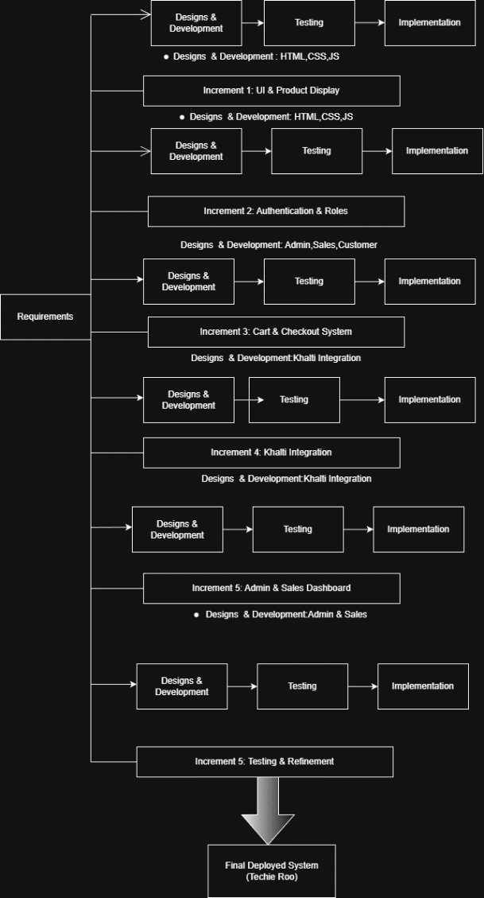
Figure 1: System Analysis and Design

REQUIREMENT IDENTIFICATION
Requirement Identification is a vital step in the system analysis phase of software development. It involves identifying and defining the essential needs and expectations that the system must fulfill to operate effectively. This process ensures that the website aligns with business objectives and provides a satisfactory experience for users. For TECHIE ROO – E-COMMERCE MOBILE PHONE STORE, requirements are categorized into functional and non-functional requirements.

Functional Analysis
Product Catalog: The website must display a variety of mobile phones, accessories, and branded products such as Apple devices. Each product should include detailed information such as name, specifications, price, images, discount offers (if available), and stock availability.
• User Account Management: Customers should be able to register, log in securely, and manage their personal information and order history through their accounts.
• Shopping Cart: The system should allow customers to add products to the cart, modify quantities, remove items, and proceed to checkout smoothly.
• Order Management: Users should be able to place orders, view order details, and track the status of their orders after purchase.
• Payment Integration: A secure payment system should be integrated using the Khalti payment gateway to process online transactions safely and reliably.
• Admin Panel: The administrator should be able to manage product listings, update prices and discounts, control inventory, and view customer orders through an admin dashboard.
• Customer Support: The website should provide WhatsApp integration to allow customers to directly contact the store for inquiries, order confirmation, and delivery-related support.

Non-Functional Analysis

Non-functional requirements describe how the system performs rather than the functions it provides. In the context of our website the non-functional requirements are as follows:
• Security: User information and payment data must be protected using secure authentication methods, encrypted communication, and safe transaction handling, especially during Khalti payment processing.
• Usability: The website should be easy to use, with a simple and intuitive interface that is accessible to both experienced and first-time users.
• Performance: The website should load quickly and respond efficiently, even during periods of high traffic, to ensure a smooth and reliable shopping experience.
- Reliability:
The system should operate consistently without frequent failures. Orders, payments, and user data should be processed accurately every time.

FEASIBILITY STUDY
A feasibility study for "Techie Roo : Mobile Ecommerce websit", is essential to determine the project's viability, potential for success, and any challenges that may arise. The feasibility study typically includes several key components:

3.1.2.1 Technical Feasibility
- Platform & Technology: The website will be developed using HTML5, CSS3, and JavaScript for front-end interface, Node.js and Express.js for back-end, and SQLite3 for database management. This tech stack is lightweight, scalable, and suitable for e-commerce applications.
- Payment Gateway Integration: Integrating Khalti payment gateway for secure and convenient online transactions for Nepali customers, along with WhatsApp integration for direct customer communication and order confirmation.
- Mobile Responsiveness & Security: Ensuring mobile compatibility for diverse user devices and implementing JWT (JSON Web Tokens) for authentication and bcryptjs for password encryption to ensure data protection.

Operational Feasibility
- Inventory Management: Implementing an automated inventory system that updates stock levels in real-time for mobile phones and accessories, with easy categorization by brand, model, and specifications.
- Order Fulfillment: Establishing relationships with local logistics companies to ensure timely product delivery, along with WhatsApp integration for real-time order tracking and customer communication.
- Customer Support: Setting up WhatsApp integration (Phone: +61 0450591073) and role-based dashboards to handle customer inquiries, returns, and service issues efficiently through admin and salesperson portals.

Schedule Feasibility

- Development Timeline: The development of the e-commerce site is estimated to take 3–4 months depending on complexity. This includes design, Node.js/Express.js back-end setup, SQLite database configuration, Khalti payment integration, WhatsApp API integration, and testing.
- Launch Plan: A phased launch with initial promotions, discounts for early adopters, and a digital marketing campaign (e.g., SEO, social media, email newsletters) to generate traffic and initial sales.

DATA MODELING
Data modeling is essential to organize and structure the data required for an e-commerce website. It ensures that information can be stored efficiently, retrieved quickly, and managed effectively. For TECHIE ROO, data modeling involves identifying key entities, their attributes, and relationships between them.

Data Flow Diagram
A Data Flow Diagram (DFD) is a visual representation of the flow of data within a system, focusing on how data enters, is processed, and exits the system. It helps understand the logical structure of the system, including key processes, data stores, and data sources/destinations.
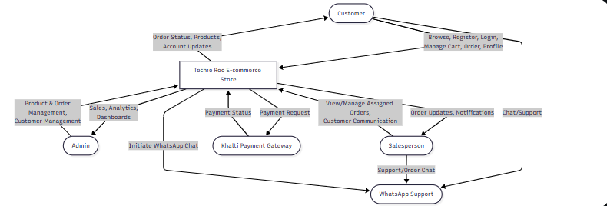

Figure 2: DFD Level 0

ER Diagram

An Entity-Relationship (ER) diagram is a visual representation of the entities within a system and the relationships between them. In the context of the Techie Roo mobile phone e-commerce website an ER diagram helps to organize and structure data to facilitate efficient database design.

TECHIE ROO E COMMERCE WEBSITE ER

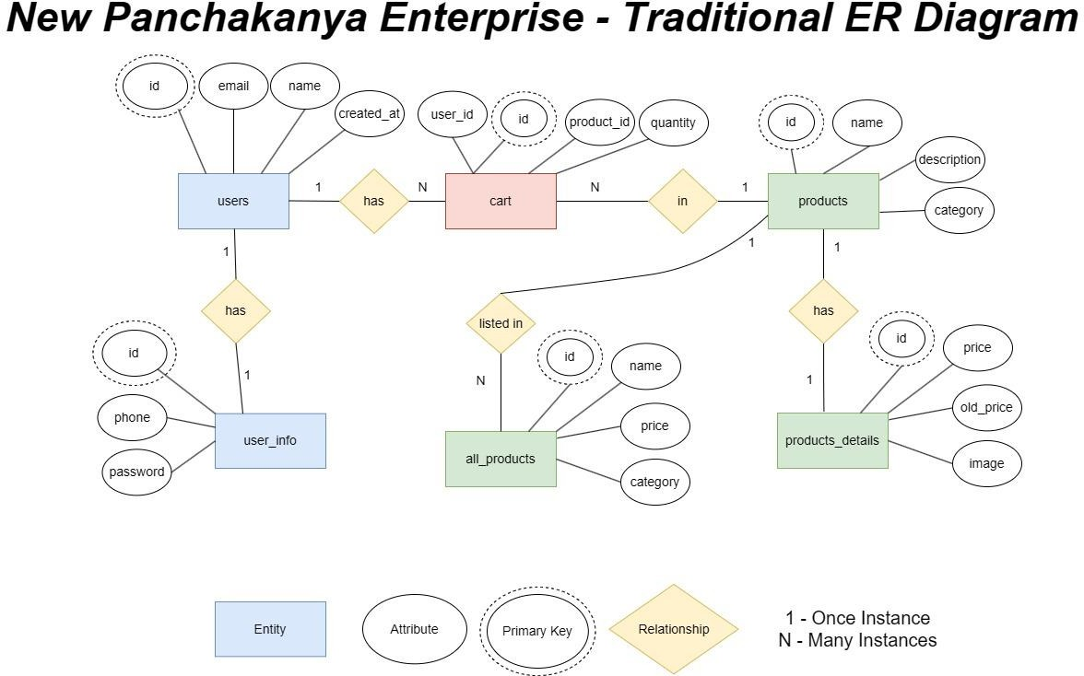

Figure 3 : ER Diagram

PROCESS MODELING
For Techie Roo mobile phone e-commerce website, the process modeling would describe the flow of operations, from the customer’s browsing experience to the final order placement and delivery. Below is a structured breakdown of the process model using relevant diagrams.

Flow Chart:

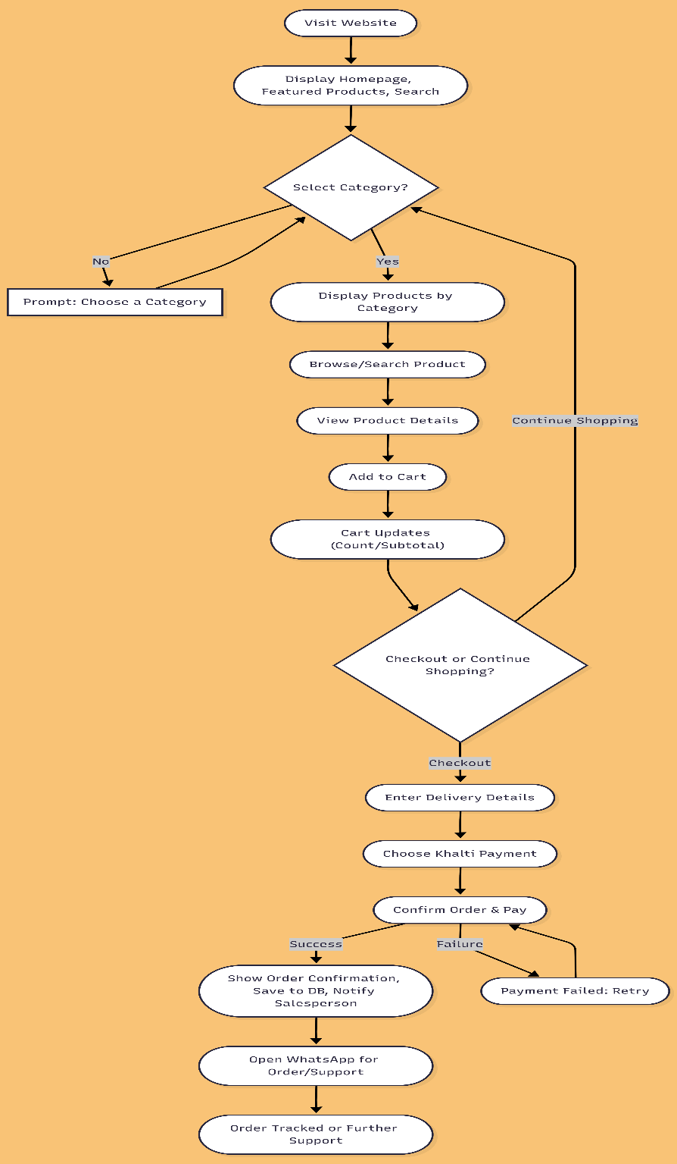
The Steps in the flowchart are as follows:
Step 1: Visit Website
- The user accesses the Techie Roo homepage: http://localhost:3000 (or live domain).
- Featured products, categories (e.g., Smartphones, Accessories), and a search bar are displayed.
Step 2: Category Selection
- Users can select a category to browse products: Smartphones, Chargers, Headphones, Cases, etc.
- Validation:
  - If no category is selected, a prompt guides the user to choose one.
  - Once selected, all products in that category are displayed.
Step 3: Browse and Search Items
- Users can browse products within the chosen category.
- Use the search bar to quickly find a specific product by name, brand, or model.

Step 4: Select Product and Add to Cart
- The user selects a product to view details (images, specifications, price, stock).
- Clicks “Add to Cart” to include it in the shopping cart.
- The shopping cart updates dynamically, showing item count and subtotal.
Step 5: Proceed to Checkout
    - Enter delivery details (address, phone number).
    - Choose Khalti as the payment method.
    - Confirm the order and complete the payment.

Step 6: Continue Shopping
    - Return to browsing products without checking out.
Step 7: Order Confirmation
- Upon successful payment:
  - An order confirmation is displayed on the website.
  - Order details are stored in the database.
  - Assigned salesperson receives a notification if applicable.
Step 8: Customer Support
- The website includes a WhatsApp icon for customer support.
- Users can click the icon to send messages or inquiries to the store directly.
- This allows seamless communication for questions, complaints, or assistance.
Outcome:
This workflow ensures a smooth shopping experience for Techie Roo customers, integrating search-based product discovery, Khalti payment, and WhatsApp support for customer communication.

Use Case Diagram

This diagram illustrates the interactions between users (Customers and Admin) and the Techie-Roo commerce platform.

Key functionalities for Customers include:

        - Browsing Phone, charger etc:-
Searching for products by category, brand (e.g., Samsung phone), or keywords
        - Viewing product details, including images, descriptions, and specifications.
        - Adding products to the cart.
        - Check out options for delivery or pickup.
        - Entering billing and shipping information.
        - Selecting payment methods.
        - Tracking order status.
        - Viewing order history.

Admin functionalities include:

        - Managing product catalog (adding, editing, deleting products).
        - Managing inventory levels.
        - Processing orders.
        - Managing customer accounts.
        - Generating sales reports.
        - Handling customer inquiries.

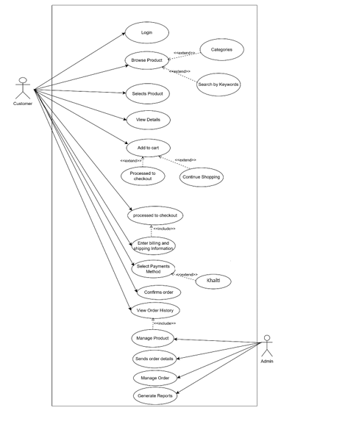
Figure 5: Use Case Diagram

Activity Diagram

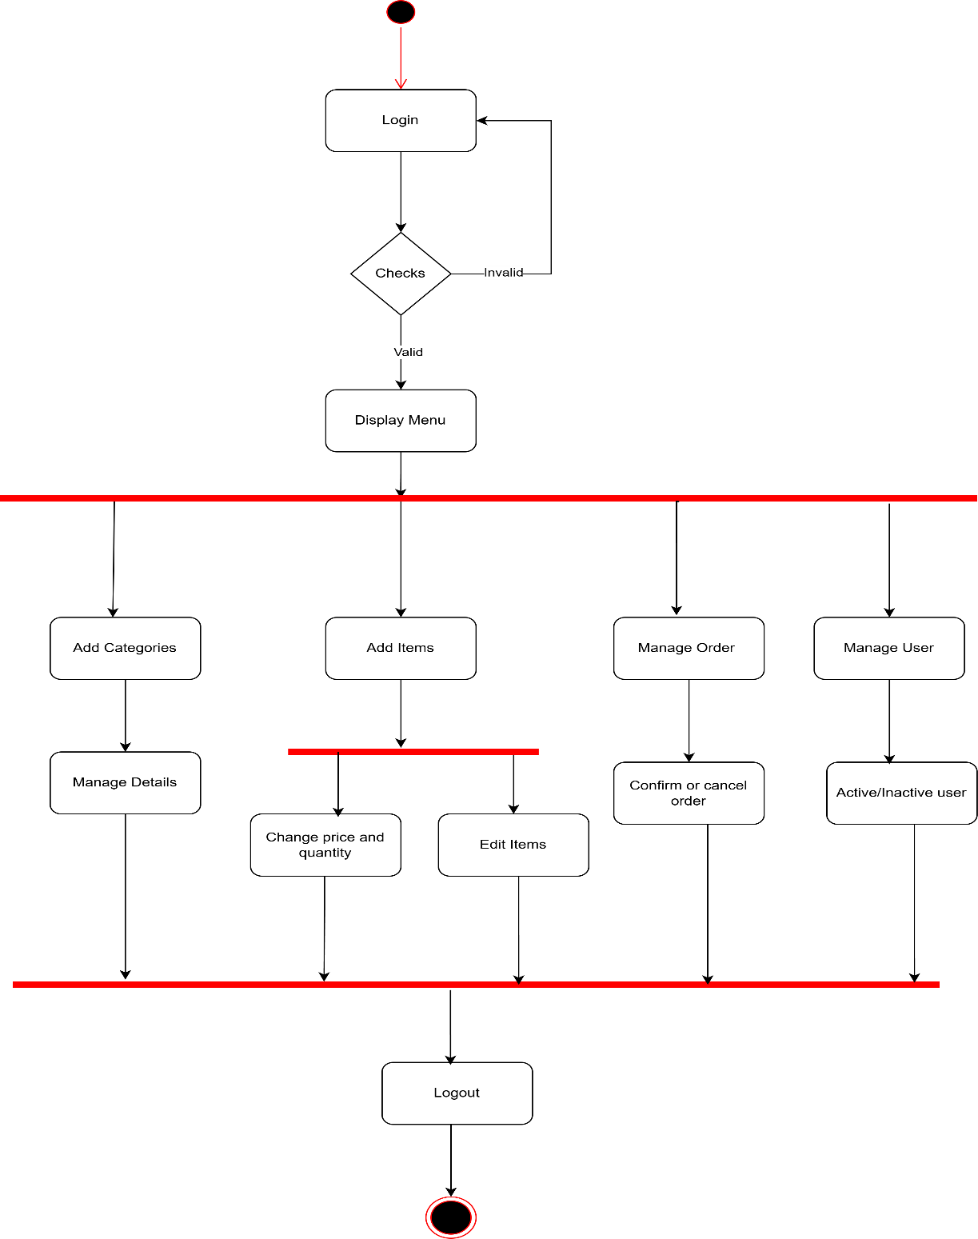
Figure 6: Activity Diagram of Admin

Key activities for admin include:

        - Login and authentication: The process begins with the admin logging into the system, followed by authentication to verify their credentials.
        - Category Management: The admin can add new categories, modify existing ones, and manage their details.
        - Item Management: The admin can add new items, edit existing items, and adjust their price and quantity.
        - Order Management: The admin has the authority to manage orders, including confirming orders and canceling orders as needed.
        - User Management: The admin can manage user accounts within the system, enabling or disabling user accounts based on requirements.

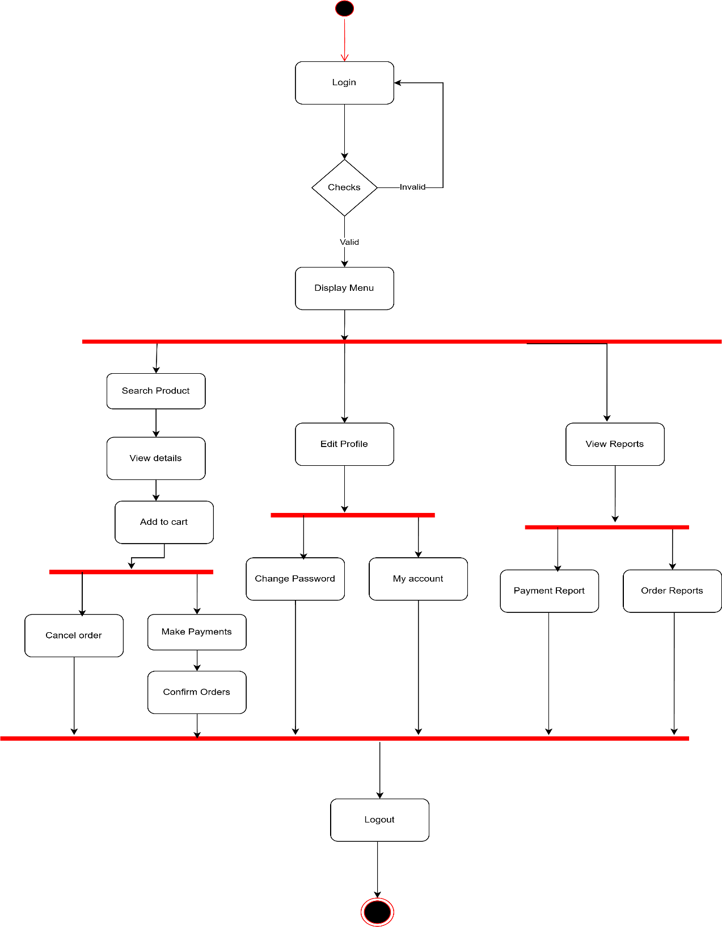
Figure 7: Activity Diagram of Customer

Key activities for customers include:

        - Login and Authentication: The user starts by logging into the system, followed by authentication to verify their credentials.
        - Product Exploration: Users can search for products, view product details, and add items to their cart.
        - Account Management: Users can edit their profile, change their password, and view their account information.
        - Order Management: Users can make payments, confirm orders, and cancel orders if needed.
        - Reporting: The system provides access to view reports, including payment reports and order reports.

Sequence Diagram

This sequence diagram represents the interaction between a User, the Web Browser, Techno Ree Server, the Database, and the Payment Gateway during various activities on an e-commerce website:

Homepage Access:
The user opens the website, and the browser requests the homepage from the server, which fetches data from the database and displays it to the user.

Product Search:
The user searches for products. The browser sends the query to the server, which retrieves matching products from the database and returns the results.

Viewing Product Details:
The user selects a product to view its details. The browser requests product information from the server, which fetches it from the database and displays it.

Adding Products to Cart:
The user adds a product to their cart. The browser sends this request to the server, which updates the cart information in the database and confirms the actions
- WhatsApp Support: Users can click the WhatsApp icon if they face issues or need assistance with using the website.

Checkout:
The user proceeds to checkout. The server retrieves carts and user details from the database and displays the checkout page.

Payment:
The user initiates payment. The browser communicates with the payment gateway, which notifies the server of payment success. The server updates the order status in the database and confirms the order to the user.
- Logout: The user logs out, and the server processes the logout request, confirming the action to the browser.

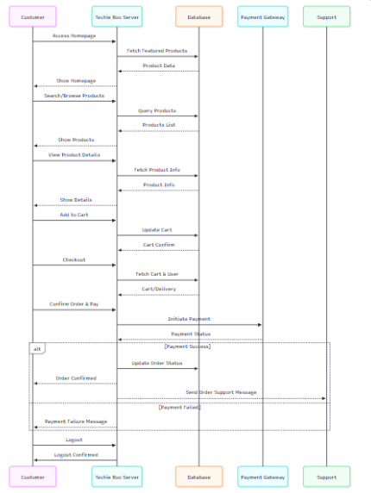

Figure 8:Sequence Diagram

SYSTEM DESIGN

Architectural Design
The three-tier architecture has been used for this project. This architecture is a client server architecture in which the functional process logic, data access, computer data storage and user interface are developed and maintained as independent modules on separate platforms.
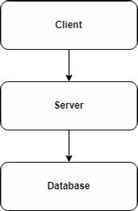

Figure 9 : Three tier architecture

Three-Tier Architecture has the following layers.

Presentation Layer:
Occupies the top level and displays information related to services available on a website. The tier communicates with other tiers by sending results to the browser and other tiers in the network.

Application Layer:
Also called the middle tier, logic tier, business logic or logic tier, this tier is pulled from the presentation tier. It controls application functionality by performing detailed processing. It is managed by a local host.

Data Layer:
Houses database servers where information is stored and retrieved. Data in this tier is kept independent of application servers or the business logic.

The database we have used here is SQL Lite3 database

The following are the reasons behind choosing three tier-architecture:

      - An ability to update the technology stack of one tier, without impacting other areas of the application.
      - It makes the logical separation among three different layers

Database Schema Design
Database schema design is a strategy for constructing a framework for data management. Just like in architecture, a solid database needs to have a blueprint to keep the project on track.
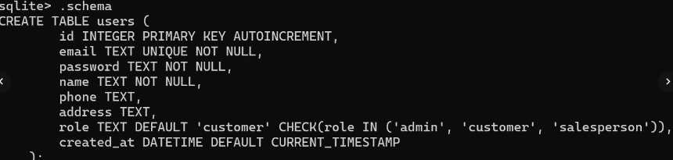

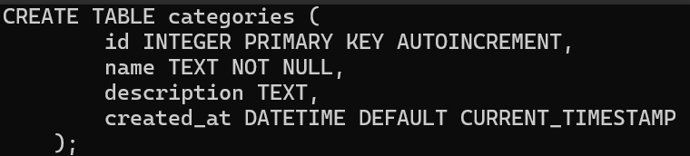

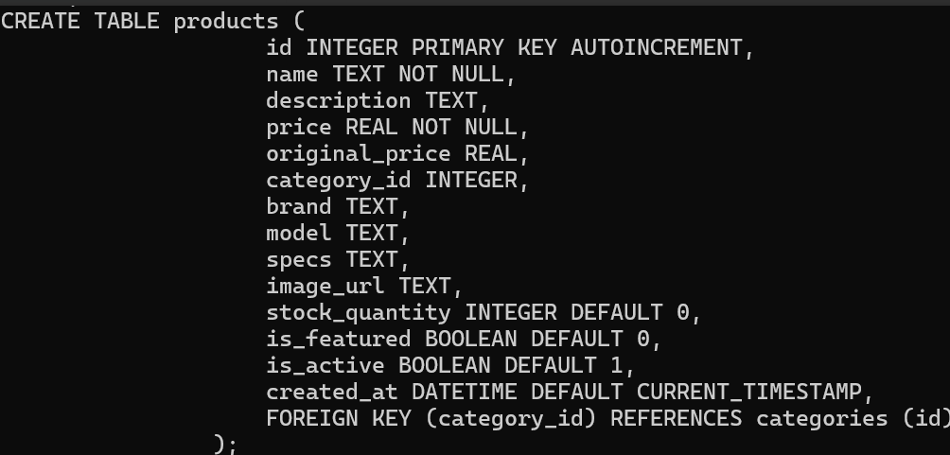

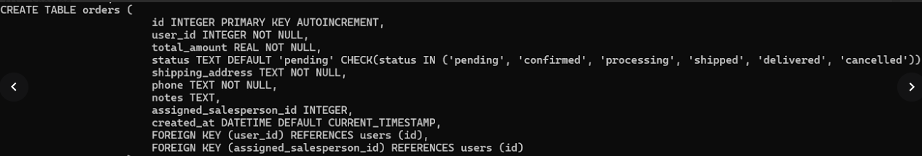
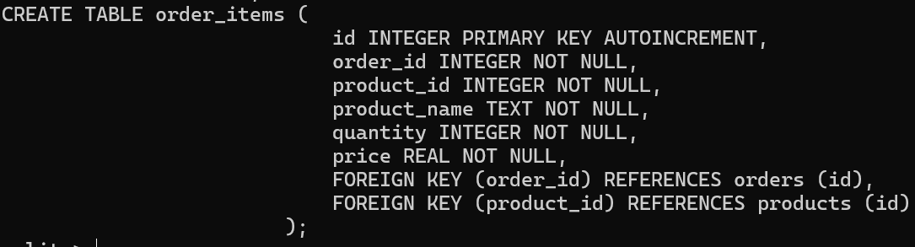
Figure 10: Database Schema

CHAPTER 4: IMPLEMENTATION AND TESTING

IMPLEMENTATION

Tools used.
      - Platform: Windows
      - Content Management System: HTML, CSS
      - Design and prototyping Tool: Mermaid

Implementation Detail of Module

The implementation of Techie Roo, an e-commerce platform for mobile phones and accessories, was carried out using a combination of modern front-end and back-end technologies to provide a responsive, secure, and user-friendly shopping experience. The front-end was developed using HTML5, CSS3, and Vanilla JavaScript, ensuring compatibility across desktops, tablets, and mobile devices. Key features include product browsing by category, search functionality for quick product discovery, a dynamic shopping cart, secure user authentication, profile management, and a WhatsApp support icon for customer inquiries. The back-end was implemented using Node.js and Express.js, handling routing, API endpoints, and server-side logic. SQLite3 serves as the database for storing user information, products, orders, and categories, with automatic creation and sample data setup on the first run. Authentication is secured with JWT (JSON Web Tokens), and passwords are hashed using bcryptjs, while Multer handles file uploads and express-validator ensures input validation. The development environment included Visual Studio Code as the code editor and a Node.js local server for testing, with SQLite3 for database management. For payment processing, the Khalti payment gateway was integrated to provide secure online transactions, while a WhatsApp icon on all pages enables real-time customer support. The system implements role-based access control, differentiating features for Customers, Admins, and Salespersons, and supports all core e-commerce functionalities, including product listings, cart management, checkout, payment processing, order tracking, and management. Overall, the implementation focuses on delivering a smooth, efficient, and secure online shopping experience tailored for mobile phone customers.

TESTING

System testing is a level of testing that validates the complete and fully integrated software product. The purpose of a system test is to evaluate the end-to-end system specifications. Usually, the software is only one element of a larger computer-based system.

Test Case ID: 1

Test Title: Verify product search and filtering functionality

Test Designed Date: December 2024

Application: Techie Roo - Mobile Phone & Accessories E-commerce Platform
Pre-conditions: User has successfully accessed the website at http://localhost:3000
Dependencies:
- Product database is populated with smartphones and accessories
- Categories include: Smartphones, Accessories, Pre-owned
- Sample products include: iPhone 15 Pro, Samsung Galaxy S24, Google Pixel 8 Pro, OnePlus 12, etc.

Table 1: Test Case 1 - Product Search and Filtering
Test Description | Test Data | Expected Result | Actual Result | Status (Pass/Fail)
Navigate to home page  Select "Smartphones" category  Verify filtered products | Category: Smartphones Filter: Category dropdown | System should display all products from the Smartphones category (iPhone 15 Pro, Samsung Galaxy S24, Google Pixel 8 Pro, OnePlus 12) | System displays filtered Smartphones products successfully | Pass

Use search functionality  Enter "iPhone" in search bar  Click search button  Verify search results | Search term: "iPhone" | System should display all iPhone products (iPhone 15 Pro, iPhone 14 Pro, iPhone 13) | System displays filtered iPhone products successfully | Pass
Test brand filter  Select "Apple" from brand dropdown  Verify filtered results | Brand filter: Apple | System should display only Apple products | System displays only Apple products successfully | Pass
Test price filter  Select "Rs. 100,000 - Rs. 150,000" price range  Verify filtered results | Price filter: 100000-150000 | System should display products within the price range | System displays products in selected price range | Pass
Attempt search with invalid product name  Enter "NonExistentProduct123" | Search term: "NonExistentProduct123" | System should display "No products found" message or empty product grid | System displays empty grid (no products) | Pass
Test combined filters  Select Category: "Pre-owned"  AND Brand: "Apple" | Category: Pre-owned Brand: Apple | System should display only pre-owned Apple products (iPhone 14 Pro, iPhone 13) | System displays filtered pre-owned Apple products | Pass
Search with partial match  Enter "charger" in search | Search term: "charger" | System should display all products with "charger" in name or description (Wireless Charger, USB-C Fast Charger 65W) | System displays matching products | Pass
Clear filters  Reset all filters to "All" | Reset filters | System should display all active products | System displays all products | Pass

Post-condition:
Search results are displayed correctly, and users can:
- View product details by clicking on a product
- Add products to cart
- See product images, prices, and descriptions
- Use multiple filters simultaneously

Additional Test Cases

Test Case ID: 2 - Shopping Cart Functionality
Test Description | Test Data | Expected Result | Actual Result | Status
Add product to cart | Product: iPhone 15 Pro  Quantity: 1 | Product added to cart, cart count increases by 1 | Cart updated | Pass
Update quantity in cart | Change quantity from 1 to 3 | Cart total updates, quantity shows 3 | Quantity updated | Pass
Remove item from cart | Click remove button | Item removed, cart count decreases | Item removed | Pass
Cart persistence | Refresh page | Cart items remain after refresh | Cart persists | Pass

Test Case ID: 3 - Checkout & Payment Flow
Test Description | Test Data | Expected Result | Actual Result | Status
Proceed to checkout (not logged in) | Click checkout without login | System shows "Please login" message | Login required | Pass
Proceed to checkout (logged in) | Valid user with cart items | Order created, redirected to Khalti | Redirects to payment | Pass
Complete payment | Khalti test credentials:  Mobile: 9800000000  OTP: 987654 | Payment verified,  order status: confirmed | Payment successful | Pass
Cancel payment | Cancel on Khalti page | Redirected to cancel page, order status: pending | Payment cancelled | Pass

Test Case ID: 4 - User Authentication
Test Description | Test Data | Expected Result | Actual Result | Status
Register new customer | Name: Test User  Email: test@example.com  Password: test123 | Account created, redirected to customer dashboard | Registration successful | Pass
Login as customer | Email: test@example.com  Password: test123 | Logged in, cart accessible | Login successful | Pass
Login as admin | Email: admin@techieroo.com  Password: admin123 | Logged in, redirected to admin dashboard | Admin access granted | Pass
Login with invalid credentials | Wrong email/password | Error message displayed | Error shown | Pass

Test Environment
- Browser: Chrome, Firefox, Safari
- Operating System: Windows 10/11
- Server: Node.js + Express
- Database: SQLite
- Payment Gateway: Khalti (Test Mode)

Test Data Summary
- Total Products: 9
- Categories: 3 (Smartphones, Accessories, Pre-owned)
- Brands: Apple, Samsung, Google, OnePlus, Generic
- Price Range: Rs. 3,898.70 - Rs. 1,169,998.70

Notes
- All prices in Nepali Rupees (Rs.)
- Images loaded from /uploads/ directory
- Cart stored in localStorage
- Authentication using JWT tokens
- Khalti test credentials used for payment testing

CHAPTER 5: CONCLUSION AND FUTHER RECOMMENDATION

LESSON LEARNT /OUTCOME
From this project, we learned about project management, how the Content Management Systems work and its application in the Ecommerce industry. We also learned to build the diagrams that are needed for the system. We learned many things which can lead us to do any work related to such a further project.

CONCLUSION
Techie Roo is a comprehensive e-commerce platform that provides customers with a seamless and efficient way to purchase mobile phones and accessories online. Built using modern web technologies such as HTML5, CSS3, JavaScript for the front-end, and Node.js with Express.js for the back-end, the system leverages SQLite for database management and integrates secure authentication using JWT and bcryptjs. With essential e-commerce features such as product browsing, search functionality, shopping cart management, checkout with Khalti payment, and order tracking, Techie Roo ensures a smooth and secure shopping experience for both customers and administrators. Additionally, the inclusion of WhatsApp support enhances customer communication and service. The project demonstrates how a custom-built, role-based e-commerce solution can effectively cater to a specific market segment, providing a practical example of a modern, niche-focused online store. System diagrams, including use case, ER, and data flow diagrams, further illustrate the platform’s architecture, highlighting its structured and user-centric design.

FUTURE RECOMMENDATION
The project will be upgraded and extended with the following features:
    - Improving the design, implementation, and documentation in such a way that anyone can use this project for better performance.
    - The web page can be made lighter so that even with low internet speed, the page can be browsed.
    - The web application will be brought to the Android application.
    - Enhance the system with email and SMS (Short Message Service) or email notifications.
    - Evolve the system by developing several versions through users’ feedback if a complete solution has not been worked out.

References

Fitzgerald, A. (2019). Web Development Journal. Retrieved from Responsive Design: The Future of E-Commerce Sites: https://www.webdevjournal.com/responsive-design-future
He, Y. (2019). Journal of Information Security. Retrieved from Cybersecurity and Online Retail: Protecting Users in the Digital Age: https://www.journalofinfosec.com/cybersecurity- online-retail
Jones, R. &. (2021). UX Design Journal. Retrieved from User Experience Design in E-Commerce: A Case Study Approach: https://www.uxdesignjournal.com/user-experience-ecommerce- case-study
Kumar, A. &. (2020). International Journal of Web Development. Retrieved from Enhancing Interactivity in E-Commerce Websites with JavaScript: https://www.ijwdjournal.com/enhancing-interactivity-javascript
Lorincz, N. (2024, May 16). 17 Ecommerce Case Studies to Inspire You. Retrieved from OptiMonk Blog: https://www.optimonk.com/ecommerce-case-studies/
Samsung eCommerce Personalization & AR Integration (2025)
https://klugeinteractive.com/case-studies/samsung/
Pathak, Chiranjivi (2024). Digital ecommerce : A case study of Daraz online shopping store in Nepal blog: https://www.theseus.fi/handle/10024/353802
E payment gateway document : https://docs.khalti.com/khalti-epayment/

Appendices

Snapshots of output:

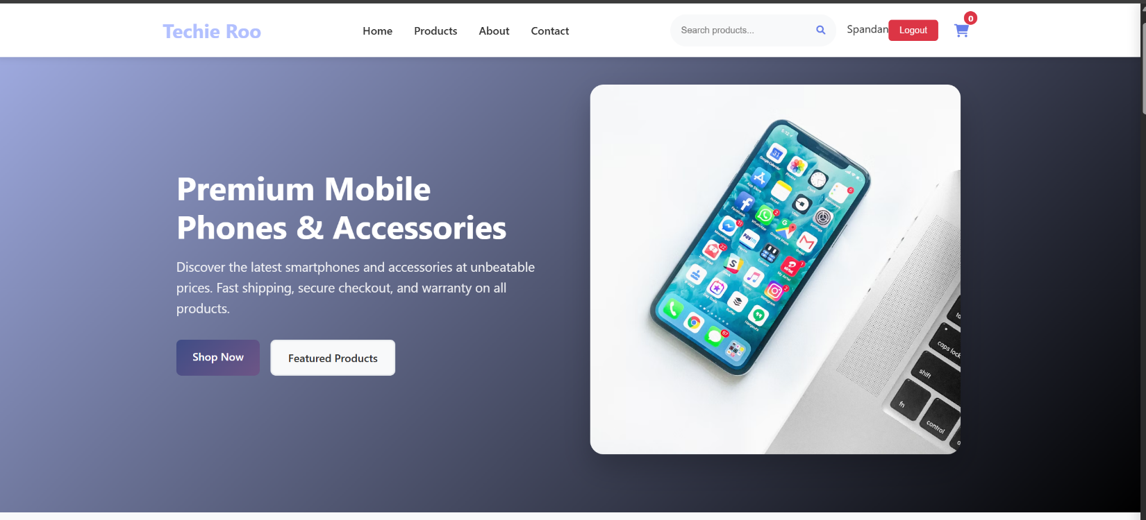

Figure 11 Home Page of Techie Roo
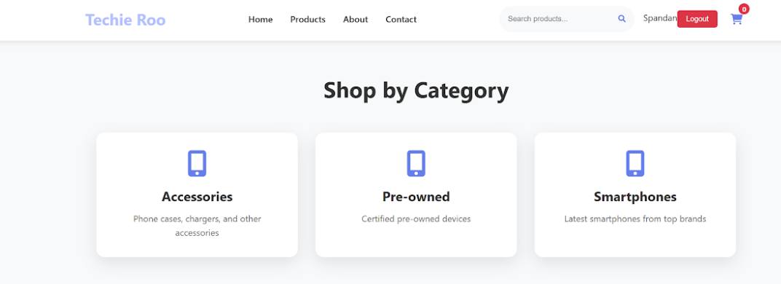
Figure 12 Shop by Category Page of Techie Roo

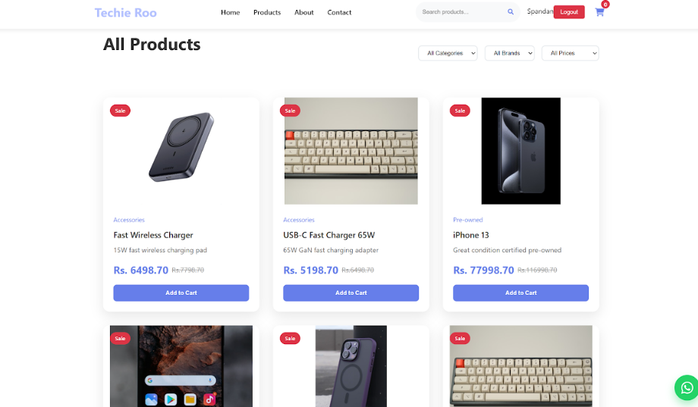
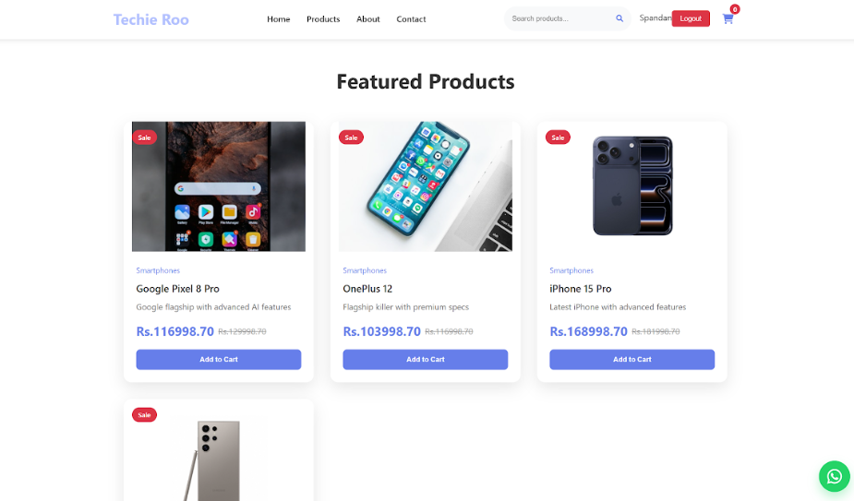

Figure 13 Product page of Techie Roo

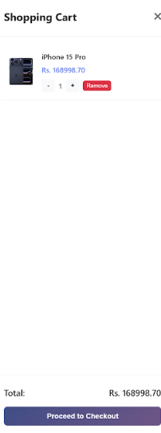
Figure 14 Add to cart page of Techie Roo
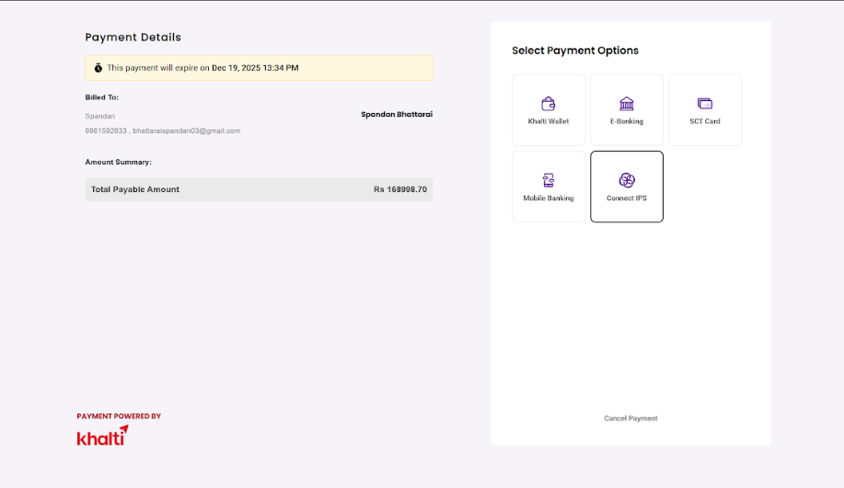

Figure 15 Payment of Techie Roo
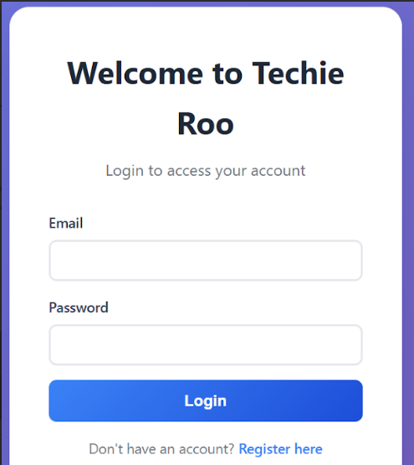
Figure 16 Login Page
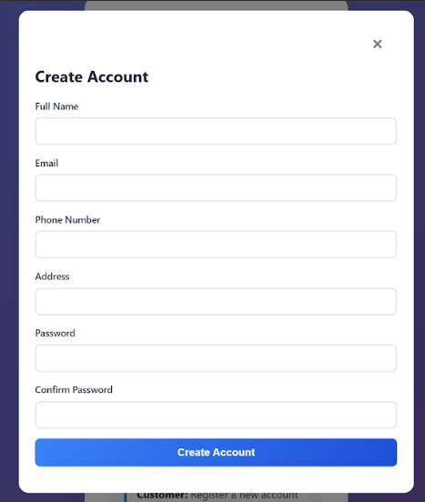

Figure 17 Signup page

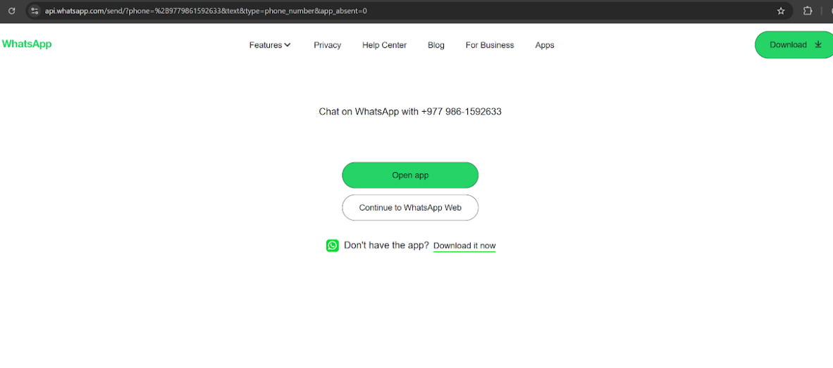
Fig 18 Whatsapp integration

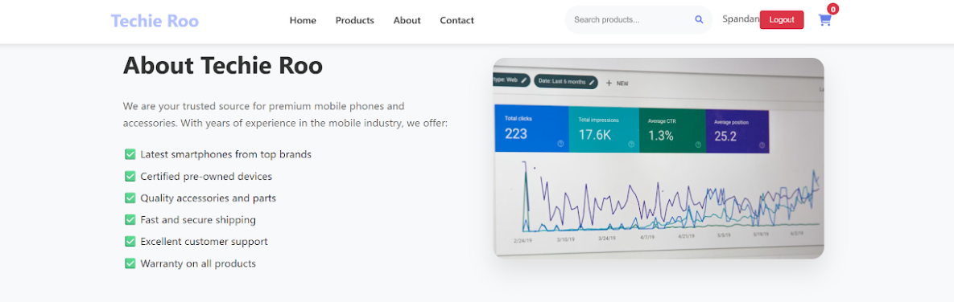

Fig 19 About page of Techie Roo

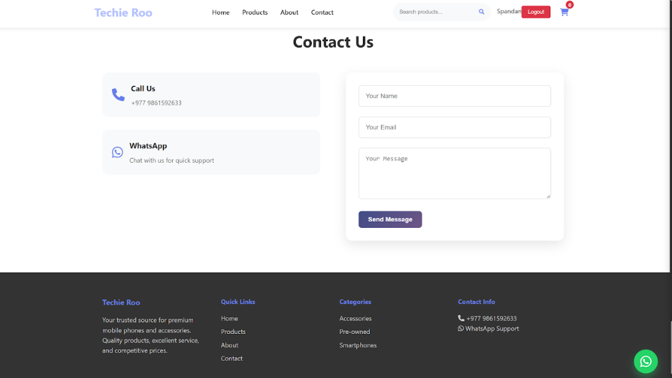

Fig 20 Contact Us of Techie Roo

